The Bone Dome

**HP Concept** **2**

The Idea;- 2

Genre;- 2

¬ Why These Genres? 2

Forms of Storytelling;- 2

¬ Why These Forms of Storytelling? 2

Features;- 2

¬ Things that Players can do, such as; 2

Player Motivation;- 2

Platform;- 2

Target Customer;- 2

Unique Selling Points;- 3

**Initial Idea / Mantra** **4**

Developed Mantra - 4

Level Design - 4

**Design Pillars** **5**

Replayability - 5

Challenge - 5

Achievement - 5

**Mechanics** **6**

Placeholder - 6

Placeholder - 6

Placeholder - 6

**Narrative / Story** **7**

Setting - 7

Characters biographies - 7

Mechanics that are introduced through the story - 7

**Art style** **8**

**Audio** **8**

**Bibliography / Image sources** **8**

# 

The Bone Dome HP

<Concept Art / Screenshot here>

# HP Concept

## The Idea;-

## Genre;-

### ¬ Why These Genres?

## Forms of Storytelling;-

### ¬ Why These Forms of Storytelling?

## Features;-

### ¬ Things that Players can do, such as;

## Player Motivation;-

## Platform;-

## Target Customer;-

## Unique Selling Points;-

Bone Rush GDD

<Concept Art / Screenshot here>

# Initial Concept

Originally, the inspiration of Bone Rush derived from PCG (Procedurally generated games), such as a Binding of Isaac and Enter the Gungeon. Taking aspects of gameplay from both games, our team decided to attempt to place our own spin on the PCG-esque market by introducing several USPs; a scaling difficulty, a first-person roguelike and the use of PCG itself to create a (to an extent) randomised dungeon.

## Developed Concept –

Bone Rush is a dark 3D First-Person Dungeon Crawler RPG set in a Neo-Romantic, Medieval Fantasy universe where the unique mechanic is that the player can fight the endgame boss at any time, who is constantly recovering health on a timer, and buffing itself in a ritual. It is targeted at players who enjoy a variety of difficult challenges that come with rewards. In addition, we’ll also reach out to trophy hunters who want a sense of accomplishment through completing various challenges to unlock achievements.

Play as a Knight, wielding a sword and shield and adventure deep into a procedurally generated crypt - with rooms varying in objectives such as from defeating all enemies to solving puzzles - to stop an ancient ritual from completion. Challenge the fates of previous adventurers by looting their items to heal and buff you in facing off against a variety of skeletons.

Choose and prioritise up to two stats that you level up during your dungeon delve. The player may crush an item to face off against the giant, sledgehammer-wielding skeleton that utilises multiple abilities. The ritual may only be interrupted during the boss fight, so the pressure is on the player to time themselves carefully.

## 

## Level Design –

### Gameplay Themes –

With PCG being an ever-present feature that our game is designed around, we had to keep this in mind when designing the blockouts for each level within the crypt. To help workflow, we split this into three separate sections:

* **Large, open combat-based rooms** – Utilising object-based cover, we can manipulate the flow of these rooms to make them dynamic based upon the player’s playstyle.
* **Corridors** - Make these as modular as possible as they will be used to connect rooms.
* **Verticality** - e.g. Towers, etc

## OPEN FLOOR PLAN, CONCEPT ONE –

## OPEN FLOOR PLAN, BLOCKOUT ONE –

Referring back to the aforementioned object-based cover, players should be able to utilise cover placed within-scene to progress throughout each room whilst successfully defeating the numerous enemies that will be present at all times.

Players should be able to navigate their way around each room/scene whilst avoiding all damage from present enemies. Currently, the above image is a placeholder environment for artists to refer to in terms of geometry and architecture. We need to rework this at a later date, finishing the scene’s look and gameplay design – this can be achieved by playtesting at a later date.

## OPEN FLOOR PLAN, GOALS –

* Reworking the layout of the room, moving objects around for appropriate gameplay once enemies have been added.
* Working with artists to achieve the final visualisation of the original room concept.

## CORRIDOR, CONCEPT ONE –

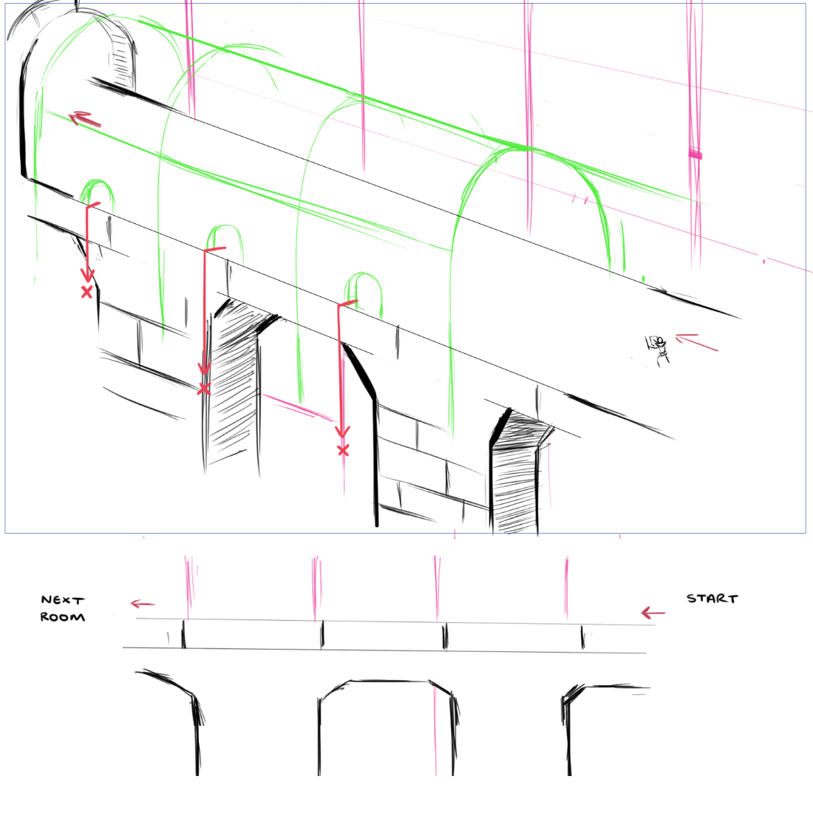

## CORRIDOR, BLOCKOUT ONE –

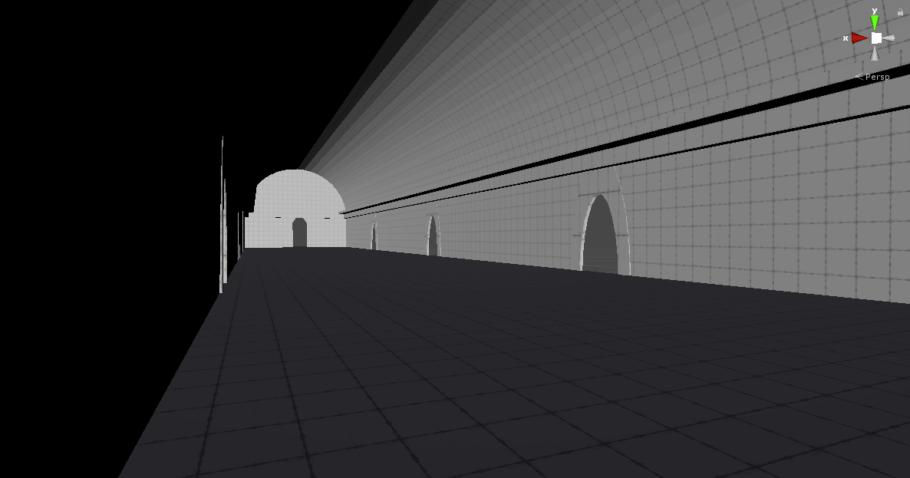

Currently, the Corridor serves as both an area-connector and a combat room for the player to experience. Being the flattest of the combat rooms so far, we will need to make several changes to address the following issues that have already been brought up in meetings during implementation phases –

* Poor Flow – The player finds themselves walking forwards, hacking and slashing their whole way through.
* Lack of visuals – Due to the nature of the corridor, it currently contains nothing but the player and enemies. This can be fixed by fleshing it out in our next revision with props and objects for the player to use as cover.
* Optimisation – Once remade with complete modular 3D models during our next revision, the corridor should run at a much higher framerate; something that’s important due to it being a persistent area-connector throughout the game.
* Visual indications – Currently it’s not obvious to the player that if they fall out of the window, they will die. We can fix this by implementing fog outside the corridor or adding a depth filter on the camera.

## VERTICAL, CONCEPT ONE –

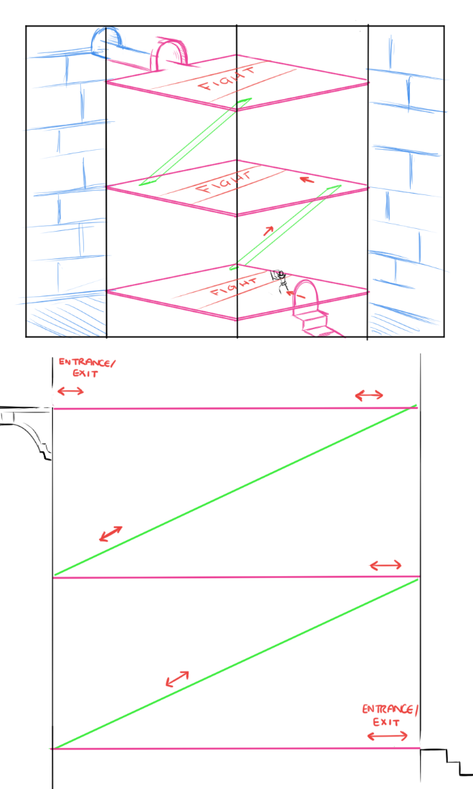

With the third section being verticality, we attempted to play with scale on a level that hasn’t been experienced by the player up until now – hopefully imposing a sense of intimidation upon them in effort to prepare them for the eventual colossal scale of the boss. As a very early design, we’ve attempted to separate this room into three differing sections – each one providing the player with a new experience. Our first floor is an open space with the aim to test the player’s survivability and mechanical skill. In a direct contrast to this, the idea behind the third floor is to provide an open-floor approach with cover, obviously increasing difficulty to compensate for the safety net of cover.

To try and split up the similarity between floors, we’ve included the second floor that’s currently concepted to be turned into a maze utilising: Walls, holes in the floor and ranged opponents. However, this concept will be implemented upon further stages of iteration.

## VERTICAL ONE, BLOCKOUT ONE –

## 

## VERTICAL ONE, GOALS –

* Implementing the second floor and playtesting the puzzle to ensure that gameplay is fluid and concise.
* Achieves the initial goals set out during concepting.
* Fleshing out – Currently our scene consists of empty rooms with pillars, our next goal should be populating the level with hazards (AI) and props for visual effect to keep our player interested.
* Lighting – Experimenting with dynamic lighting to help entrap the player in the fear of claustrophobia, misleading them due to the full room actually being expansive and open.

## VERTICAL TWO, BLOCKOUT TWO –

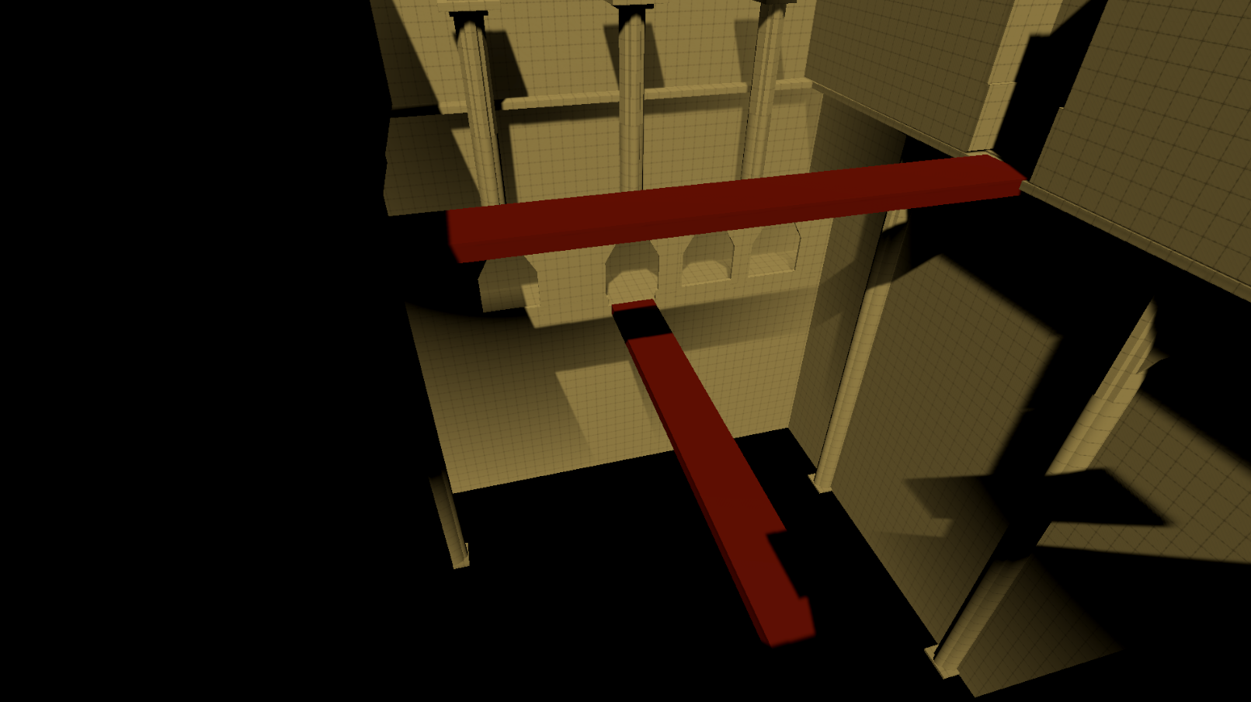

Vertical Two is a blockout scene centred around a much more linear style than the first iteration. Taking heavy design inspiration from Sen’s Fortress in the Dark Souls series, the player enters the scene and is presented with all information needed to progress throughout the level; a technique commonly used within RPG Level Design to ensure the player isn’t confused whilst attempting to keep a smooth flow of gameplay. Artistically wise though, we derived inspiration from the Shadow of Colossus in terms of architecture and geometry; allowing for artists to create modular assets based off these blockout references.

Currently the issues that have been presented throughout light playtesting have been the following –

* Lack of visual interest. This can be worked upon by filling the scenes with props and lighting, using said lighting to guide the player throughout the dark crypt that they find themselves within.
* Length. Due to the AI not being finished, it’s hard to tell currently whether the length of the level is expansive enough compared to the other   
  blockouts that are present within the project currently.
* Lack of mechanical play. Due to the openness of the room currently, players are forced into a simple melee of blocking and attacking continuously – something that will become tedious especially once pitted against ranged opponents on the second floor.

## VERTICAL TWO, GOALS –

* Playtest thoroughly once AI has been fully implemented and iterate upon the design where needed to complete fluid flow for the player to follow.
* Fleshing out with props once models have been created and textured to help satisfy the visual aid of the Player, helping them become immersed in the world around them.
* Experiment with adding environmental hazards to the level to further complicate the player’s position within the scene.

# Design Pillars

## Replayability –

## Challenge –

## Achievement –

# Mechanics

## Placeholder 1 –

## Placeholder 2 –

## Placeholder 3 –

# Narrative / Story

## Setting –

## Characters biographies –

## Mechanics that are introduced through the story –

# Art

## Themes –

## Characters –

## Placeholder –

# Audio

## Music –

Music will be non-diegetic. Regarding style, it will be orchestral, featuring mainly dark and heroic elements in different areas of the game, also taking features from music during the Middle Ages such as organum and fusing them with intense music. Chanting was also a feature of music during the Middle Ages, so combining this with the boss’ ritual will be effective in portraying the scene and suspending the disbelief of the player. This decision was made in order to contribute to the experience of a medieval-fantasy universe.

Additionally, the music will adapt to various parameters in the game through utilising FMOD Studio. For instance, the boss fight will be accompanied by a piece of music that adapts to the boss’ health. In this case, the music will adapt through a BossHP parameter: as the boss’ health parameter decreases, the music becomes increasingly intense via fading in additional layers of the music or transitioning into a different section when the boss’ health reaches key points (such as 75% health, 50% health, 25% health, etc.). The piece will shift between dark and heroic throughout the battle, which makes sense because the heroism could portray that the player is saving the world (and therefore is being heroic), but the darkness could portray that the boss is demonic and powerful. This piece will begin with a grand homophonic motif to introduce the boss, but then decrease in intensity to represent the early stage of the battle where it has begun but no blow has been struck yet.

There will also be music for large rooms where the objective would take longer to complete, though this music will be more subtle to not heavily distract the player. In combat-oriented rooms, the music will adapt to the number of enemies engaged in combat with the player, so when more enemies surround the player, it is more intense (which will be done by fading in additional layers such as additional percussion and/or ostinatos).

A musical cue will also play approximately thirty seconds before the boss finishes the ritual, which will contribute to the player’s experience because it will raise intensity by reminding the player of the timer; it serves as a warning that the player is about to lose. This cue will be dark and chaotic, potentially atonal, which would reflect the ritual’s completion.

## Sound effects –

There will be sound effects for player movement (chainmail and leather armour) which will contribute to the suspension of disbelief in the player. Further regarding movement, there will be a variety of footstep sounds that will change depending on the material that is stepped on. This will help communicate movement because it can serve as a substitute for the player not being able to see their legs.

Additionally, SFX for the swinging of the player’s sword are needed, and this will be randomised through FMOD. There will also be SFX for the collision of the sword with the enemies. Similar sounds for enemy weapons will also be necessary, such as an arrow being launched from a bow and subsequent sounds of an arrow hitting or missing the player. Further considering weaponry, distinct and powerful sounds for the boss’ sledgehammer are needed to portray the sheer scale and strength of the boss.

UI Sounds will also be created for hovering over and clicking on the buttons.

## Ambience –

In simulating the area of a dark crypt full of undead skeletons, the ambience will be composed of distant rattling bones, ominous wind and rat squeaks. These will enrich the atmosphere of the ominous crypt.

In the late-game, there will be rhythmically rattling bones to portray the ritual nearing completion, utilising musique-concrte which would create tension in this stage of the game.

## Voiceover –

# Bibliography / Image sources